Experiment No. 5
Name : Rinoy Kuriyakose
Aim: Roll No: 56
Simulate the following CPU scheduling algorithms to find the turn around time and waiting time.
- FCFS
- SJF
- Round Robin (Pre-emptive)
- Priority.
FCFS Scheduling :

Program:

#include<stdio.h>
void main()
{
struct process{
int no;
float bt;
float at;
float tat;
float wt;
};
int n,i,j;
float time=0,temp1,temp2,temp3,avgtat,avgwt,stat=0,swt=0;
printf("no. of processes :");
scanf("%d",&n);
struct process p[n];
printf("burst time for the processes :\n");
for(i=0;i<n;i++){
printf("p[%d] : ",i+1);
scanf("%f",&p[i].bt);
}
printf("arrival time for the processes :\n");
for(i=0;i<n;i++){
printf("p[%d] : ",i+1);
scanf("%f",&p[i].at);
}
for(i=0;i<n;i++){
p[i].no = i+1;
}
for(i=0;i<n;i++){
for(j=0;j<n-i-1;j++){
if(p[j].at>p[j+1].at){
temp1 = p[j].no;
temp2 = p[j].bt;
temp3 = p[j].at;
p[j].no = p[j+1].no;
p[j].bt = p[j+1].bt;
p[j].at = p[j+1].at;
p[j+1].no = temp1;
p[j+1].bt = temp2;
p[j+1].at = temp3;
}
}
}
for(i=0;i<n;i++){
if(time<=p[i].at){
time =p[i].at;
}
time = time + p[i].bt;
p[i].tat = time-p[i].at;
stat = stat + p[i].tat;
p[i].wt = p[i].tat - p[i].bt;
swt = swt + p[i].wt;
}
avgtat = stat/n;
avgwt = swt/n;
printf("\n process | burst time | arrival time | turn-around time | waiting time \n");
printf(" ------------------------------------------------------------------------------\n");
for(i=0;i<n;i++){
printf(" p[%d] : ",p[i].no);
printf(" %.3f ns",p[i].bt);
printf(" %.3f ns",p[i].at);
printf(" %.3f ns",p[i].tat);
printf(" %.3f ns\n\n",p[i].wt);
}
printf(" average turn-around time : %.3f ns\n",avgtat);
printf(" average waiting time : %.3f ns\n",avgwt);
}
Output:

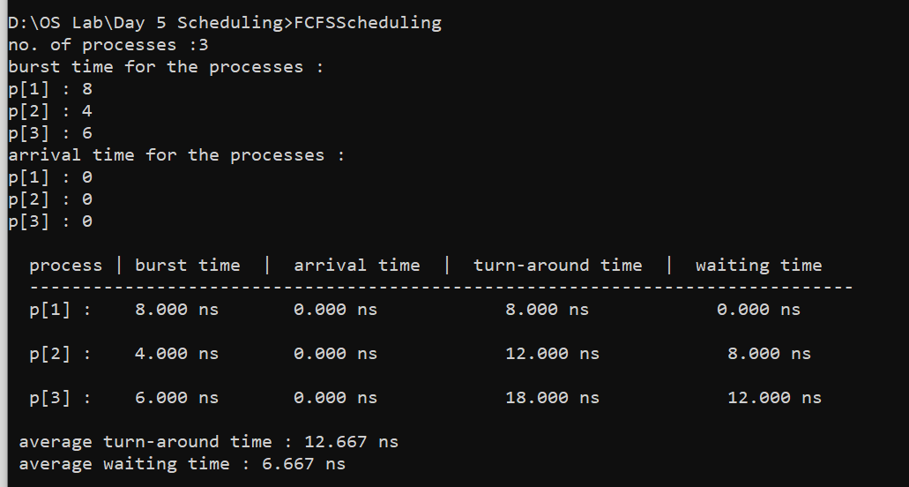
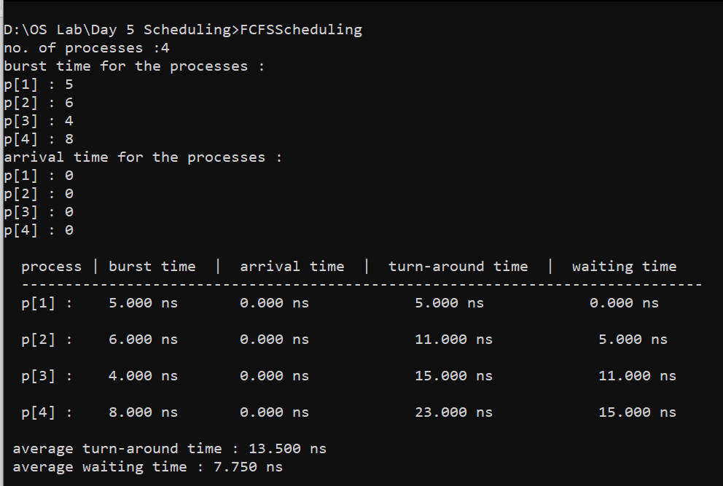

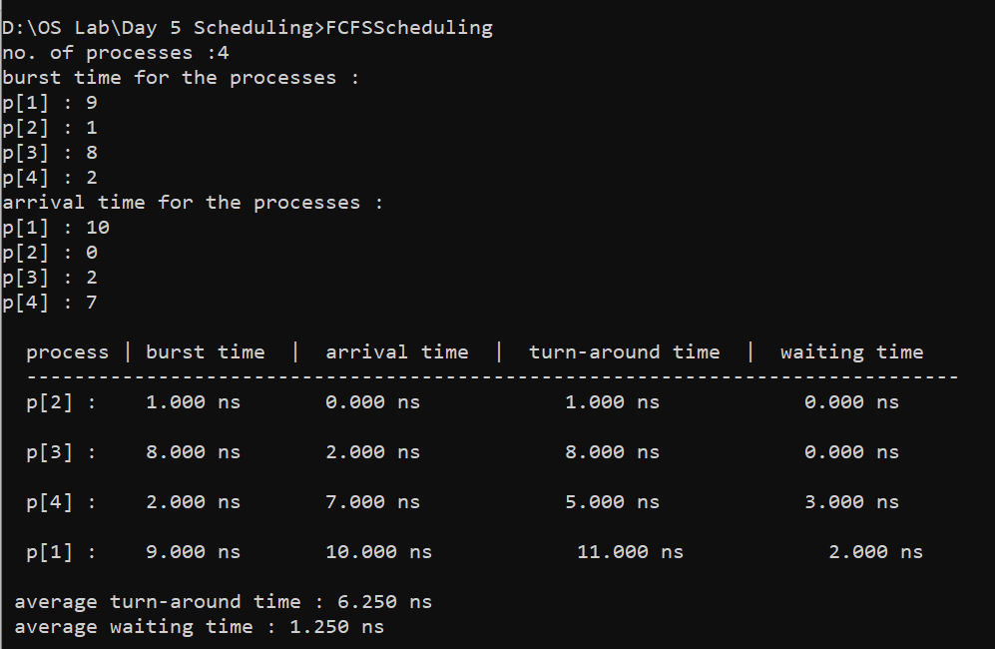

SJF Scheduling :

Program:
include<stdio.h>
void main()
{
struct process{
int no;
float bt;
float at;
float tat;
float wt;
};
int n,i,j,d,k=1;
float time=0,temp1,temp2,temp3,avgtat,avgwt,stat=0,swt=0,min,sum,btime;
printf("no. of processes :");
scanf("%d",&n);
struct process p[n];
printf("burst time for the processes :\n");
for(i=0;i<n;i++){
printf("p[%d] : ",i+1);
scanf("%f",&p[i].bt);
}
printf("arrival time for the processes :\n");
for(i=0;i<n;i++){
printf("p[%d] : ",i+1);
scanf("%f",&p[i].at);
}
for(i=0;i<n;i++){
p[i].no = i+1;
}
for(i=0;i<n;i++){
for(j=0;j<n-i-1;j++){
if(p[j].bt>p[j+1].bt){
temp1 = p[j].no;
temp2 = p[j].bt;
temp3 = p[j].at;
p[j].no = p[j+1].no;
p[j].bt = p[j+1].bt;
p[j].at = p[j+1].at;
p[j+1].no = temp1;
p[j+1].bt = temp2;
p[j+1].at = temp3;
}
}
}
for(i=0;i<n;i++){
for(j=0;j<n-i-1;j++){
if(p[j].at>p[j+1].at){
temp1 = p[j].no;
temp2 = p[j].bt;
temp3 = p[j].at;
p[j].no = p[j+1].no;
p[j].bt = p[j+1].bt;
p[j].at = p[j+1].at;
p[j+1].no = temp1;
p[j+1].bt = temp2;
p[j+1].at = temp3;
}
}
}
for(j=0;j<n;j++){
btime=btime+p[j].bt;
min=p[k].bt;
for(i=k;i<n;i++){
if ((btime>=p[i].at) && (p[i].bt<min)){
min = p[i].bt;
temp1 = p[i].no;
temp2 = p[i].bt;
temp3 = p[i].at;
p[i].no = p[k].no;
p[i].bt = p[k].bt;
p[i].at = p[k].at;
p[k].no = temp1;
p[k].bt = temp2;
p[k].at = temp3;
}
}
k++;
}
sum = p[0].at;
for(i=0;i<n;i++){
if(sum<p[i].at){
sum=p[i].at;
}
sum = sum + p[i].bt;
p[i].tat=sum-p[i].at;
p[i].wt=p[i].tat-p[i].bt;
stat=stat+p[i].tat;
swt=swt+p[i].wt;
}
avgtat = stat/n;
avgwt = swt/n;
printf("\n process | burst time | arrival time | turn-around time | waiting time \n");
printf(" ------------------------------------------------------------------------------\n");
for(i=0;i<n;i++){
printf(" p[%d] : ",p[i].no);
printf(" %.3f ns",p[i].bt);
printf(" %.3f ns",p[i].at);
printf(" %.3f ns",p[i].tat);
printf(" %.3f ns\n\n",p[i].wt);
}
printf(" average turn-around time : %.3f ns\n",avgtat);
printf(" average waiting time : %.3f ns\n",avgwt);
}

Output:

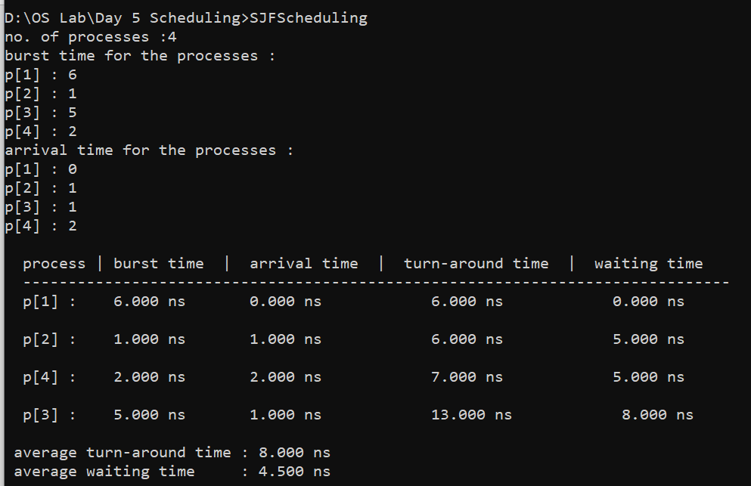

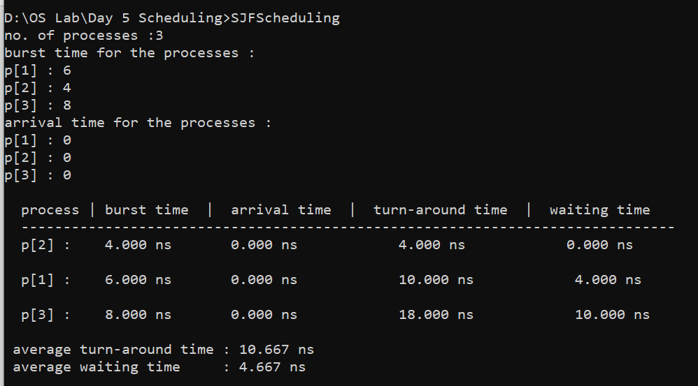

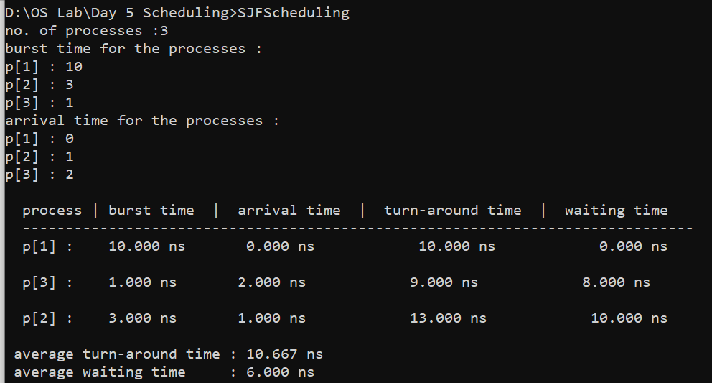

Round Robin Scheduling :

Program:
#include<stdio.h>
void main()
{
struct process{
int no;
float bt;
float at;
float tat;
float wt;
};
int n,i,j,quantum,count,var;
float time=0,temp1,temp2,temp3,temp4,avgtat,avgwt,stat=0,swt=0,sum;
printf(" no. of processes :");
scanf("%d",&n);
struct process p[n];
float temp[n];
printf(" burst time for the processes :\n");
for(i=0;i<n;i++){
printf(" p[%d] : ",i+1);
scanf("%f",&p[i].bt);
temp[i]=p[i].bt;
}
printf(" arrival time for the processes :\n");
for(i=0;i<n;i++){
printf(" p[%d] : ",i+1);
scanf("%f",&p[i].at);
}
for(i=0;i<n;i++){
p[i].no = i+1;
}
printf(" time quantum for the processes: ");
scanf("%d", &quantum);
for(i=0;i<n;i++){
for(j=0;j<n-i-1;j++){
if(p[j].at>p[j+1].at){
temp1 = p[j].no;
temp2 = p[j].bt;
temp3 = p[j].at;
temp4 = temp[j];
p[j].no = p[j+1].no;
p[j].bt = p[j+1].bt;
p[j].at = p[j+1].at;
temp[j] = temp[j+1];
p[j+1].no = temp1;
p[j+1].bt = temp2;
p[j+1].at = temp3;
temp[j+1] = temp4;
}
}
}
sum=p[0].at;
var=n;
for( i = 0; var!=0; ){
if(temp[i] <= quantum && temp[i] > 0){
sum = sum + temp[i];
temp[i] = 0;
count=1;
}
else if(temp[i] > 0){
temp[i] = temp[i] - quantum;
sum = sum + quantum;
}
if(temp[i]==0 && count==1){
var--;
p[i].tat=sum-p[i].at;
p[i].wt=sum-p[i].at-p[i].bt;
swt = swt+p[i].wt;
stat = stat+p[i].tat;
count =0;
}
if(i==n-1){
i=0;
}
else if(p[i+1].at<=sum){
i++;
}
/*else if(p[i+1].at>=sum){
sum=p[i+1].at;
i++;
}*/
else{
i=0;
}
}
avgtat = stat/n;
avgwt = swt/n;
printf("\n process | burst time | arrival time | turn-around time | waiting time \n");
printf(" ------------------------------------------------------------------------------\n");
for(i=0;i<n;i++){
printf(" p[%d] : ",p[i].no);
printf(" %.3f ms",p[i].bt);
printf(" %.3f ms",p[i].at);
printf(" %.3f ms",p[i].tat);
printf(" %.3f ms\n\n",p[i].wt);
}
printf(" average turn-around time : %.3f ms\n",avgtat);
printf(" average waiting time : %.3f ms\n",avgwt);
}

Output:

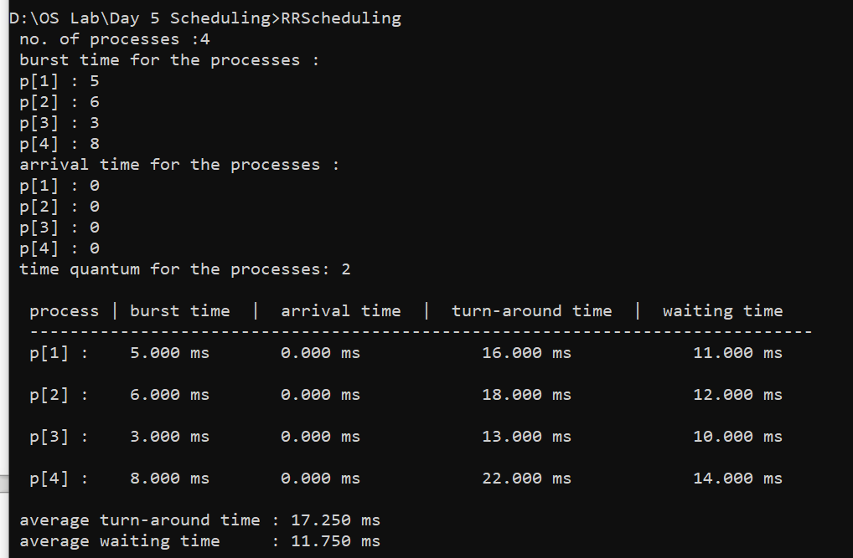

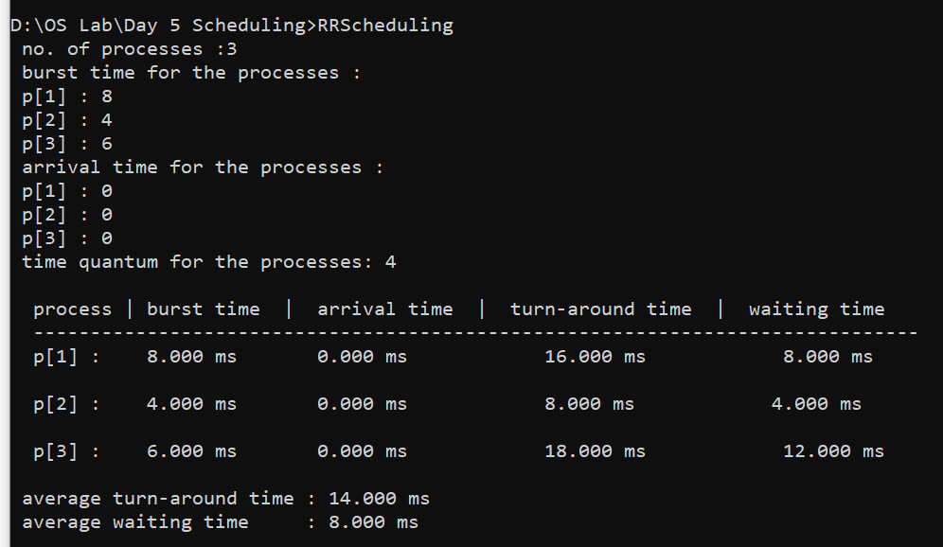

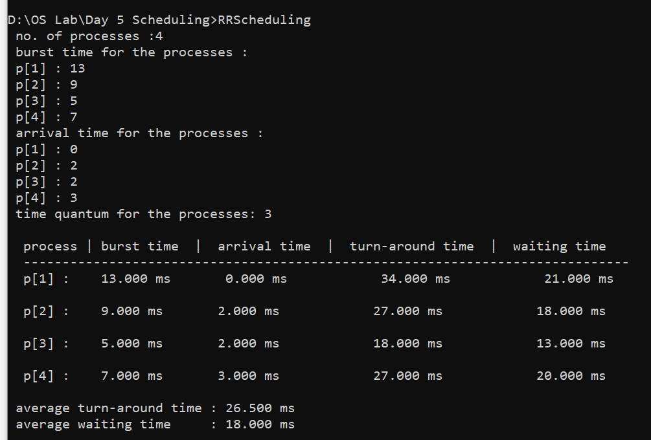

Priority Scheduling :

Program:
#include<stdio.h>
void main()
{
struct process{
int no;
float bt;
float at;
float tat;
float wt;
int pr;
};
int n,i,j,d,k=1,min,temp4;
float time=0,temp1,temp2,temp3,avgtat,avgwt,stat=0,swt=0,sum,btime;
printf("no. of processes :");
scanf("%d",&n);
struct process p[n];
printf("burst time for the processes :\n");
for(i=0;i<n;i++){
printf("p[%d] : ",i+1);
scanf("%f",&p[i].bt);
}
printf("arrival time for the processes :\n");
for(i=0;i<n;i++){
printf("p[%d] : ",i+1);
scanf("%f",&p[i].at);
}
printf("priority for the processes :\n");
for(i=0;i<n;i++){
printf("p[%d] : ",i+1);
scanf("%d",&p[i].pr);
}
for(i=0;i<n;i++){
p[i].no = i+1;
}
for(i=0;i<n;i++){
for(j=0;j<n-i-1;j++){
if(p[j].pr>p[j+1].pr){
temp1 = p[j].no;
temp2 = p[j].bt;
temp3 = p[j].at;
temp4 = p[j].pr;
p[j].no = p[j+1].no;
p[j].bt = p[j+1].bt;
p[j].at = p[j+1].at;
p[j].pr = p[j+1].pr;
p[j+1].no = temp1;
p[j+1].bt = temp2;
p[j+1].at = temp3;
p[j+1].pr = temp4;
}
}
}
for(i=0;i<n;i++){
for(j=0;j<n-i-1;j++){
if(p[j].at>p[j+1].at){
temp1 = p[j].no;
temp2 = p[j].bt;
temp3 = p[j].at;
temp4 = p[j].pr;
p[j].no = p[j+1].no;
p[j].bt = p[j+1].bt;
p[j].at = p[j+1].at;
p[j].pr = p[j+1].pr;
p[j+1].no = temp1;
p[j+1].bt = temp2;
p[j+1].at = temp3;
p[j+1].pr = temp4;
}
}
}
for(j=0;j<n;j++){
btime=btime+p[j].bt;
min=p[k].pr;
for(i=k;i<n;i++){
if ((btime>=p[i].at) && (p[i].pr<min)){
min = p[i].pr;
temp1 = p[i].no;
temp2 = p[i].bt;
temp3 = p[i].at;
temp4 = p[i].pr;
p[i].no = p[k].no;
p[i].bt = p[k].bt;
p[i].at = p[k].at;
p[i].pr = p[k].pr;
p[k].no = temp1;
p[k].bt = temp2;
p[k].at = temp3;
p[k].pr = temp4;
}
}
k++;
}
sum = p[0].at;
for(i=0;i<n;i++){
if(sum<p[i].at){
sum=p[i].at;
}
sum = sum + p[i].bt;
p[i].tat=sum-p[i].at;
p[i].wt=p[i].tat-p[i].bt;
stat=stat+p[i].tat;
swt=swt+p[i].wt;
}
avgtat = stat/n;
avgwt = swt/n;
printf("\n process | burst time | arrival time | priority | turn-around time | waiting time \n");
printf(" -------------------------------------------------------------------------------------------\n");
for(i=0;i<n;i++){
printf(" p[%d] : ",p[i].no);
printf(" %.3f ns",p[i].bt);
printf(" %.3f ns",p[i].at);
printf(" %d",p[i].pr);
printf(" %.3f ns",p[i].tat);
printf(" %.3f ns\n\n",p[i].wt);
}
printf(" average turn-around time : %.3f ns\n",avgtat);
printf(" average waiting time : %.3f ns\n",avgwt);
}

Output:

